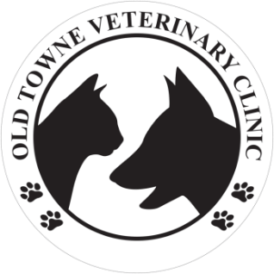
At Old Towne Veterinary Clinic, we continue to prioritize the health and safety of our clients, staff members, their families, and our community. Due to new social distancing guidelines from the Federal Government we will be implementing new processes.

PATIENT INTAKE PROTOCOL
Effective March 23, 2020 at 8:00am we will be changing our intake protocol for all non-emergency appointments.
Our new scheduled appointment intake protocol is:
- Upon arrival in our parking lot, clients will remain in their vehicle with their pet.
- Clients will call our main clinic number, 571-719-6635, to notify us of their arrival and will give a description of their vehicle.
- A technician and/or assistant will come to the client’s vehicle and bring the pet(s) inside for evaluation.
- Once the pet is in the exam room the technician and/or assistant will call the client’s cell phone to obtain a history while pet is examined by the doctor. The client will receive recommendations and a treatment plan. Verbal consent for treatment and any outpatient estimates will be authorized over the phone.
- An Old Towne Veterinary Clinic staff member will then obtain payment information via phone and an invoice and all discharge instructions will be sent to the client via e-mail.
- A technician or assistant will return the pet to the owner.

WHAT WE’RE ASKING OF YOU
Plan ahead for your pets. We recommend having a 2 week supply of food, medications, and sanitary supplies, as well as an identified friend or family member who can help care for your pet if needed, in the event you or a member of your family becomes ill.
Utilize our on-line pharmacy for prescription food requests, supplement & medication renewals. It is easier and quicker for us to approve these items. Access our on-line pharmacy here or on our website.
All clients who have COVID-19 like symptoms are asked to reschedule any appointments or send another authorized agent to present their pet to our clinic. If you or members of your family have been required or asked to be quarantined for any reason, or test positive for COVID-19, and you have visited our facility, we kindly ask you to please alert our clinic.
Please be patient during this time of limited staff. We will try to accommodate each client in a manner that adheres to the quality and standards we uphold at Old Towne Veterinary Clinic.
In case of emergency, during non-operational hours please contact:
Artemis Veterinary Emergency & Specialty Services at Phone: (703) 722-9159

